User interface design

1. Creating screen images

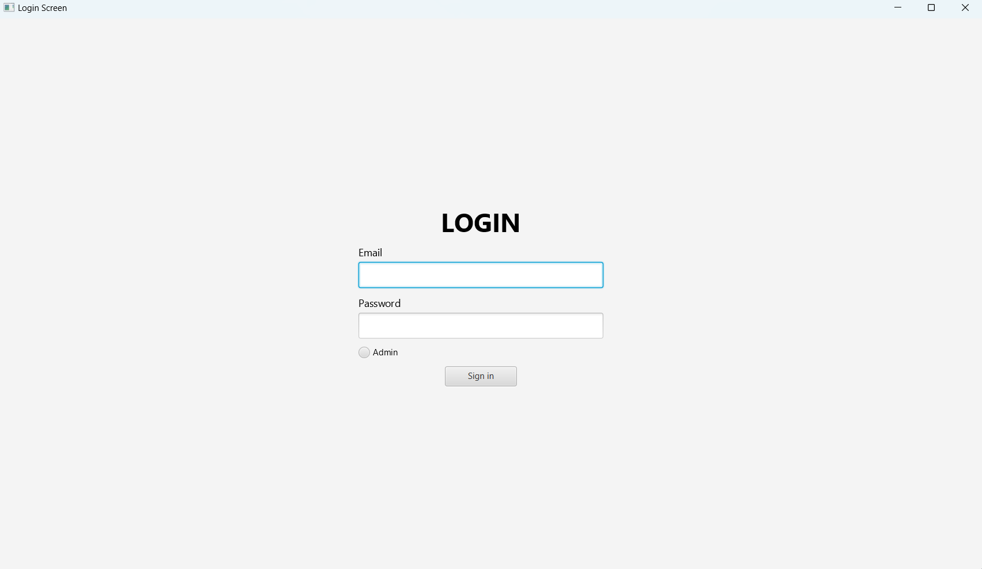

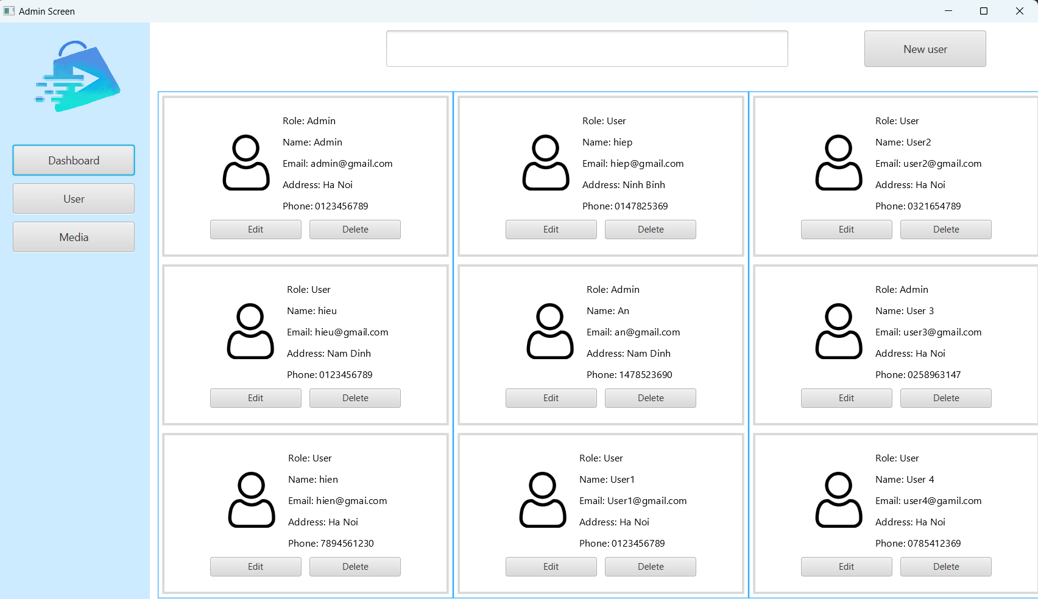

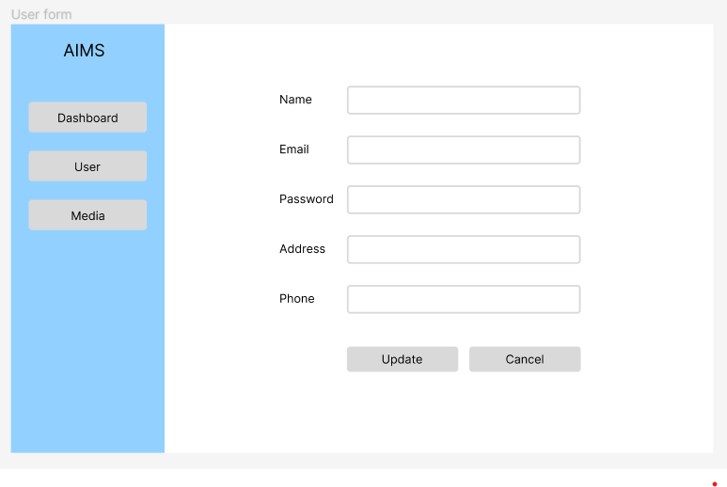

1. Transition

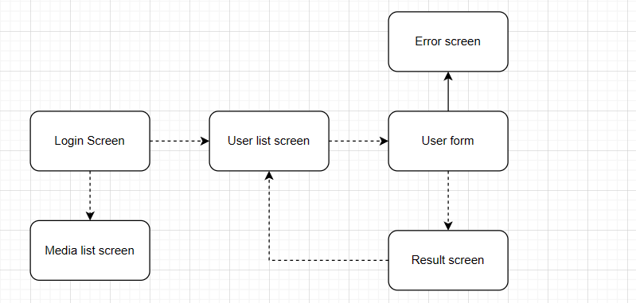

1. Screen specification

|  |  |  |  |  |  |  |
| --- | --- | --- | --- | --- | --- | --- |
| AIMS sofware | | Date of creation | Approved by | Reviewed by | Perision in change | |
| Screen specification | Login screen |  |  |  | Doãn Văn Hiếu | |
|  | | Control | Operation | Funtion | | Format |
| Email input | Input |  | | Text |
| Password input | Input |  | | Text |
| Radio button | Click | Login as user or admin | |  |
| Sign in button | Click | Check user in db and login | |  |

|  |  |  |  |  |  |
| --- | --- | --- | --- | --- | --- |
| AIMS sofware | | Date of creation | Approved by | Reviewed by | Perision in change |
| Screen specification | User list screen |  |  |  | Doãn Văn Hiếu |
|  | | Control | Operation | Funtion | |
| New user button | Click | Show form to add new user | |
| Edit button | Click | Show form to edit user | |
| Delete button | Click | Delete user | |
|

|  |  |  |  |  |  |  |
| --- | --- | --- | --- | --- | --- | --- |
| AIMS sofware | | Date of creation | Approved by | Reviewed by | Perision in change | |
| Screen specification | User form screen |  |  |  | Doãn Văn Hiếu | |
|  | | Control | Operation | Funtion | | Format |
| User name input | Input |  | | Text |
| Email input | Input |  | | Text |
| Address input | Input |  | | Text |
| Phone input | Input |  | | Text |
| Password input | Input |  | | Text |
|
| New button | Click | Add new User | |  |
| Cancel button | Click | Go back user list screen | |  |